Rodrigo Brasil 10/2023

1. **Explain each of the three A’s as you would to a non-technical family member. Use an analogy or a story.**
   1. Imagine you are in a building and want to enter a room. Authentication is like having the right key to access a room in a building. Authorization is about deciding what you're allowed to do once you enter it. Accounting is keeping a record of all your actions while you're there.
   2. Together, these three A's help ensure the security and proper management of computer networks.
2. **What should the administrator do if the ACS server fails to authenticate a user during AAA implementation?**
   1. The admin should verify the user credentials to see if they are correct, check if there is a network connection and check if the server is up.
3. **What is the role of the NAS in the AAA implementation using an ACS server? Use a diagram.**
   1. The NAS acts as a gatekeeper between the user device and the ACS server, handling the initial authentication request, enforcing authorization policies, and sending accounting data to the ACS server. The ACS server, on the other hand, performs the actual authentication, determines access privileges, and keeps track of user activity.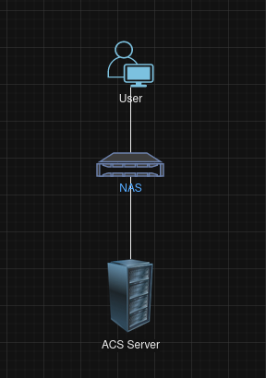

1. **What are the benefits of using RADIUS for authentication and authorization?**
   1. Some benefits of using RADIUS are the scalability it can hold a large number of users, remote access control, its flexible has a variety of authentication methods, integration it can easily be added to an existing network and security.
2. **What is RADIUS and what does it stand for?**
   1. RADIUS stands for “Remote Authentication Dial-In User Service” and it's a network protocol and system that provides centralized authentication, authorization, and accounting (AAA) management for users who connect and access a network or networked services.
3. **Research: What encryption algorithms does RADIUS use?**
   1. RADIUS uses IPsec (Internet Protocol Security), TLS (Transport Layer Security), EAP (Extensible Authentication Protocol), MS-CHAP (Microsoft Challenge Handshake Authentication Protocol), CHAP (Challenge Handshake Authentication Protocol) and PAP (Password Authentication Protocol).